微算機系統 2025
MICROPROCESSOR SYSTEMS

4-stage Pipeline CPU

Group 34

110590042 柳艾德
112590002 林羿安

Content

Instruction | Instruction code |  |  | usage | Result
Instruction | opcode | Rs | Rt | usage | Result
Load | 0000 | 2bit | 2bit | Load Rs Data | Rs←Data
Move | 0001 |  |  | Move Rs, Rt | Rs←Rt
Add | 0010 |  |  | Add Rs, Rt | Rs←Rs + Rt
And | 0011 |  |  | And Rs, Rt | Rs←Rs & Rt
Sub(A-B) | 0101 |  |  | Sub Rs, Rt | Rs←Rs – Rt
Sub(B-A) | 1001 |  |  | Sub Rs, Rt | Rs←Rt - Rs
Nor | 0110 |  |  | Nor Rs, Rt | Rs←Rs Nor Rt
Slt | 0100 |  |  | Slt Rs, Rt | if (Rs<Rt) Rs=1;else Rs=0
Div | 1000 |  |  | Div Rs, Rt | Rs←Rs / Rt
This week’s lab focuses on designing a simple 4-stage pipelined CPU capable of executing basic arithmetic and logic operations. The CPU includes a small register file with four 8-bit registers and uses RS and RT fields to select source and destination operands. Instructions are input manually through switches and move through stages for fetching, decoding, execution, and write-back. Forwarding logic is implemented to handle data hazards without stalling, and LEDs are used to show the status of each pipeline stage, while seven-segment displays reflect register values and input data in real time.

Process & Results
處理流程利用 process 同時執行的特性來模擬 pipeline 的結構，並將 each stage 所需的 register content 用 signal 的方式儲存，方便資料的傳遞。並利用 valid buffer 來控制 stage 的啟動和關閉。
- Each Stage
IF： | 依照 Lab8 Port Map 讀取指令
ID： | 把 Fetch 的 Instruction 所得的 Rs & Rt Address 轉換成 Data
EXE： | 將 Data(Rs & Rt) 通過 Opcode 取得 Result
WB： | 將 Result 寫回 Rs 所指向的 Register File (燈亮即寫回)
- Display
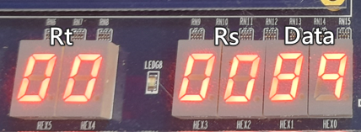 | 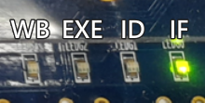
- PS
- Opcode “1111” 為 NOP
- Div 未實作
- Hazard 未實作

- Test Data
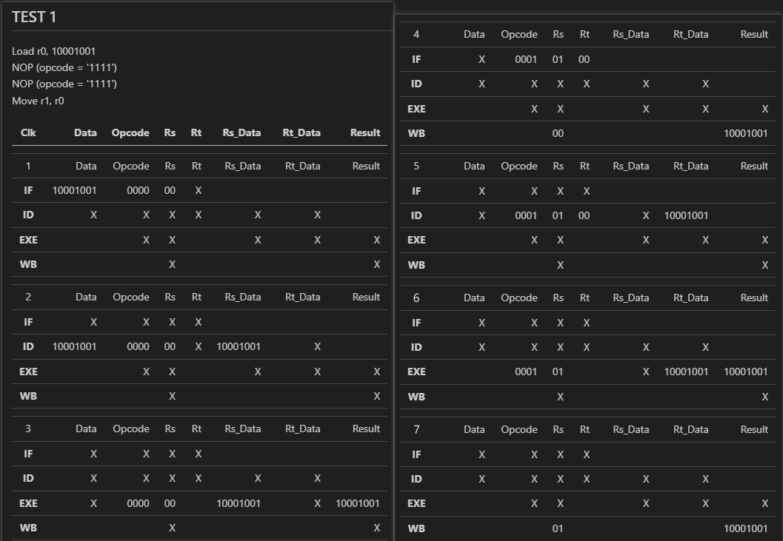
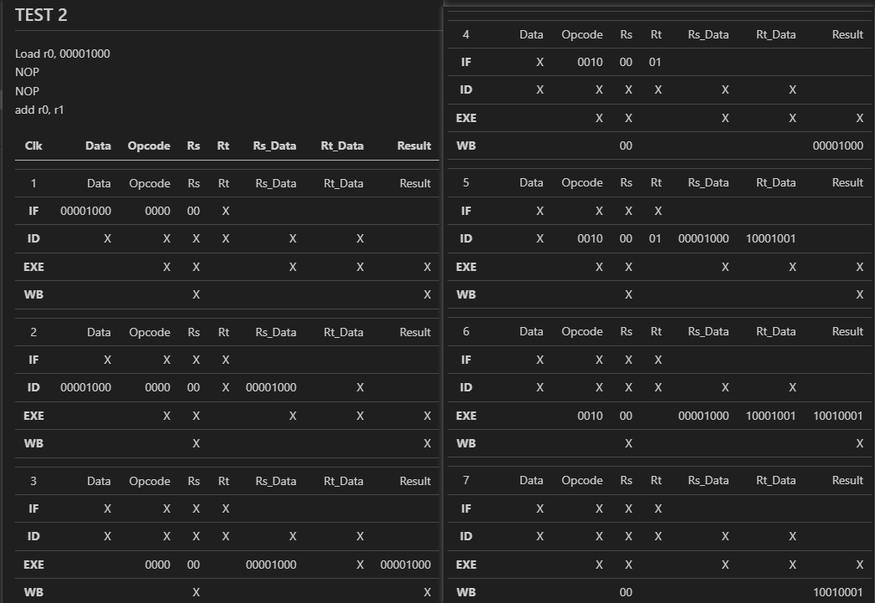
[TEST 1]
Clk = 1, Load 00, 0x89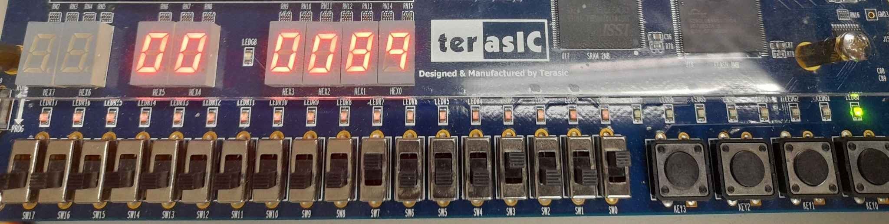
Clk = 4, Move 01, 00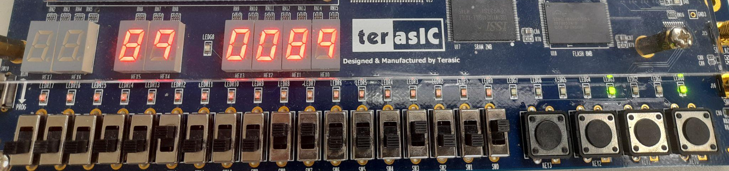
Clk = 7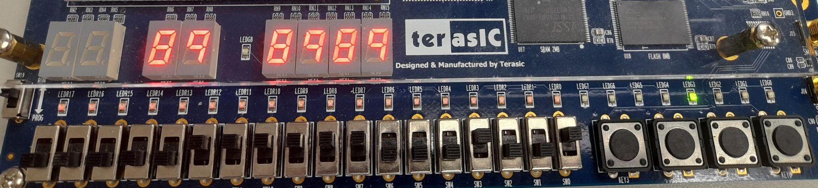

[TEST 2]
Clk = 1, Load 00, 0x08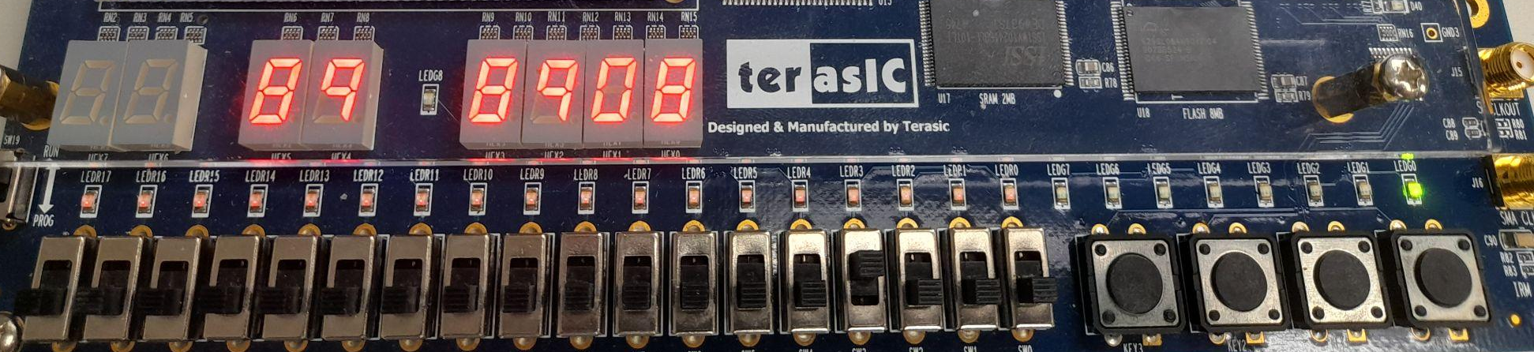
Clk = 4, Add 00, 01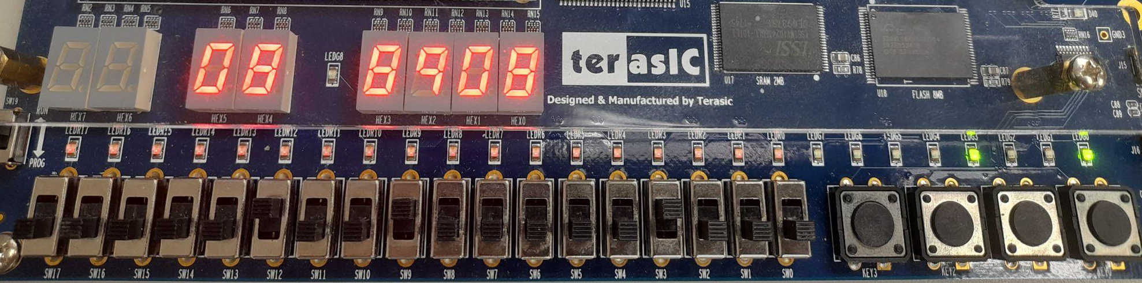
Clk = 7, Result = 0x08 + 0x89 = 0x91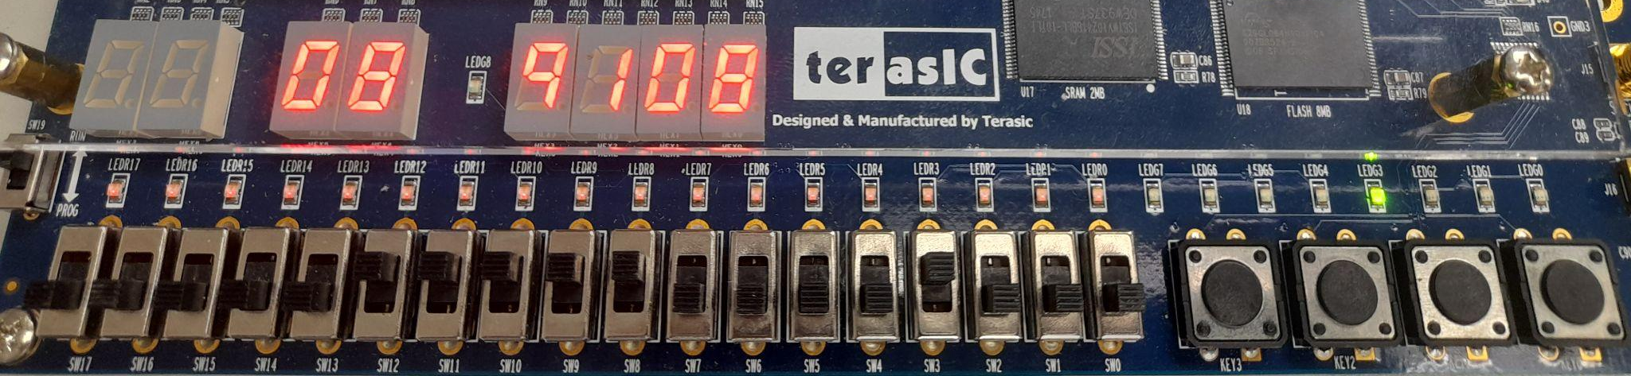

Code

LIBRARY IEEE;
USE IEEE.STD_LOGIC_1164.ALL;
USE IEEE.NUMERIC_STD.ALL;
USE work.MyPackage.ALL;
ENTITY SampleCPU IS
PORT (
-- button input
clk : IN STD_LOGIC;
-- switches input
Opcode : IN STD_LOGIC_VECTOR(3 DOWNTO 0);
Rs : IN STD_LOGIC_VECTOR(1 DOWNTO 0);
Rt : IN STD_LOGIC_VECTOR(1 DOWNTO 0);
Data : IN STD_LOGIC_VECTOR(7 DOWNTO 0);
-- Hex output
HEX0, HEX1, HEX2, HEX3, HEX4, HEX5 : OUT STD_LOGIC_VECTOR(6 DOWNTO 0);
-- Stage
LEDG : out STD_LOGIC_VECTOR(3 DOWNTO 0)
-- LEDR : out std_logic;
);
END SampleCPU;
ARCHITECTURE Behavioral OF SampleCPU IS
type reg_array is array (0 to 3) of STD_LOGIC_VECTOR(7 downto 0);
signal reg_file : reg_array := (others => (others => '0')); -- r0 ~ r3
signal valid : std_logic_vector(3 downto 0) := (others => '0');
-- IF/ID pipeline registers
signal IF_ID_Data : STD_LOGIC_VECTOR(7 downto 0);
signal IF_ID_Opcode : STD_LOGIC_VECTOR(3 downto 0);
signal IF_ID_Rs : STD_LOGIC_VECTOR(1 downto 0);
signal IF_ID_Rt : STD_LOGIC_VECTOR(1 downto 0);
-- ID/EXE pipeline registers
signal ID_EXE_Opcode : STD_LOGIC_VECTOR(3 downto 0);
signal ID_EXE_Rs : STD_LOGIC_VECTOR(1 downto 0);
signal ID_EXE_Rt : STD_LOGIC_VECTOR(1 downto 0);
signal ID_EXE_Rs_Data : STD_LOGIC_VECTOR(7 downto 0);
signal ID_EXE_Rt_Data : STD_LOGIC_VECTOR(7 downto 0);
-- EXE/WB pipeline registers
signal EXE_WB_Rs : STD_LOGIC_VECTOR(1 downto 0);
signal EXE_WB_Result : STD_LOGIC_VECTOR(7 downto 0);
signal rs_seg, rt_seg : STD_LOGIC_VECTOR(7 downto 0);
BEGIN
-- IF
process(clk)
begin
if rising_edge(clk) then
if Opcode = "1111" then -- NOP
valid(0) <= '0';
else
valid(0) <= '1';
IF_ID_Data <= Data;
IF_ID_Opcode <= Opcode;
IF_ID_Rs <= Rs;
IF_ID_Rt <= Rt;
end if;
end if;
end process;
-- ID
process(clk)
begin
if rising_edge(clk) then
if valid(0) = '0' then
valid(1) <= '0';
else
valid(1) <= '1';
ID_EXE_Opcode <= IF_ID_Opcode;
ID_EXE_Rs <= IF_ID_Rs;
ID_EXE_Rt <= IF_ID_Rt;
if IF_ID_Opcode = "0000" then -- Load
ID_EXE_Rs_Data <= IF_ID_Data;
else
ID_EXE_Rs_Data <= reg_file(to_integer(unsigned(IF_ID_Rs)));
end if;
ID_EXE_Rt_Data <= reg_file(to_integer(unsigned(IF_ID_Rt)));
end if;
end if;
end process;
-- EXE
process(clk)
variable result : std_logic_vector(7 downto 0) := (others => '0');
begin
if rising_edge(clk) then
if valid(1) = '0' then
valid(2) <= '0';
else
valid(2) <= '1';
case ID_EXE_Opcode is
when "0000" => -- Load rs <= data
result := ID_EXE_Rs_Data;
when "0001" => -- Move rs <= rt
result := ID_EXE_Rt_Data;
when "0010" => -- Add
result := std_logic_vector(unsigned(ID_EXE_Rs_Data) + unsigned(ID_EXE_Rt_Data));
when "0011" => -- And
result := std_logic_vector(unsigned(ID_EXE_Rs_Data) and unsigned(ID_EXE_Rt_Data));
when "0101" => -- Sub: rs - rt
result := std_logic_vector(unsigned(ID_EXE_Rs_Data) - unsigned(ID_EXE_Rt_Data));
when "1001" => -- Sub: rt - rs
result := std_logic_vector(unsigned(ID_EXE_Rt_Data) - unsigned(ID_EXE_Rs_Data));
when "0110" => -- Nor
result := std_logic_vector(not (unsigned(ID_EXE_Rs_Data) or unsigned(ID_EXE_Rt_Data)));
when "0100" => -- Slt
if unsigned(ID_EXE_Rs_Data) < unsigned(ID_EXE_Rt_Data) then
result := "00000001";
else
result := "00000000";
end if;
when "1000" => -- Div
-- TODO:
when others =>
result := (others => '0');
end case;
EXE_WB_Rs <= ID_EXE_Rs;
EXE_WB_Result <= result;
end if;
end if;
end process;
-- WB
process(clk)
begin
if rising_edge(clk) then
if valid(2) = '0' then
valid(3) <= '0';
else
valid(3) <= '1';
reg_file(to_integer(unsigned(EXE_WB_Rs))) <= EXE_WB_Result;
end if;
end if;
end process;
-- Output
LEDG <= valid; -- Show the stage of the CPU
rs_seg <= reg_file(to_integer(unsigned(Rs)));
rt_seg <= reg_file(to_integer(unsigned(Rt)));
BusHex0: HexDisplay port map(Hex => Data(3 downto 0), Seg => HEX0);
BusHex1: HexDisplay port map(Hex => Data(7 downto 4), Seg => HEX1);
RsHex0: HexDisplay port map(Hex => rs_seg(3 downto 0), Seg => HEX2);
RsHex1: HexDisplay port map(Hex => rs_seg(7 downto 4), Seg => HEX3);
RtHex0: HexDisplay port map(Hex => rt_seg(3 downto 0), Seg => HEX4);
RtHex1: HexDisplay port map(Hex => rt_seg(7 downto 4), Seg => HEX5);
END Behavioral;

